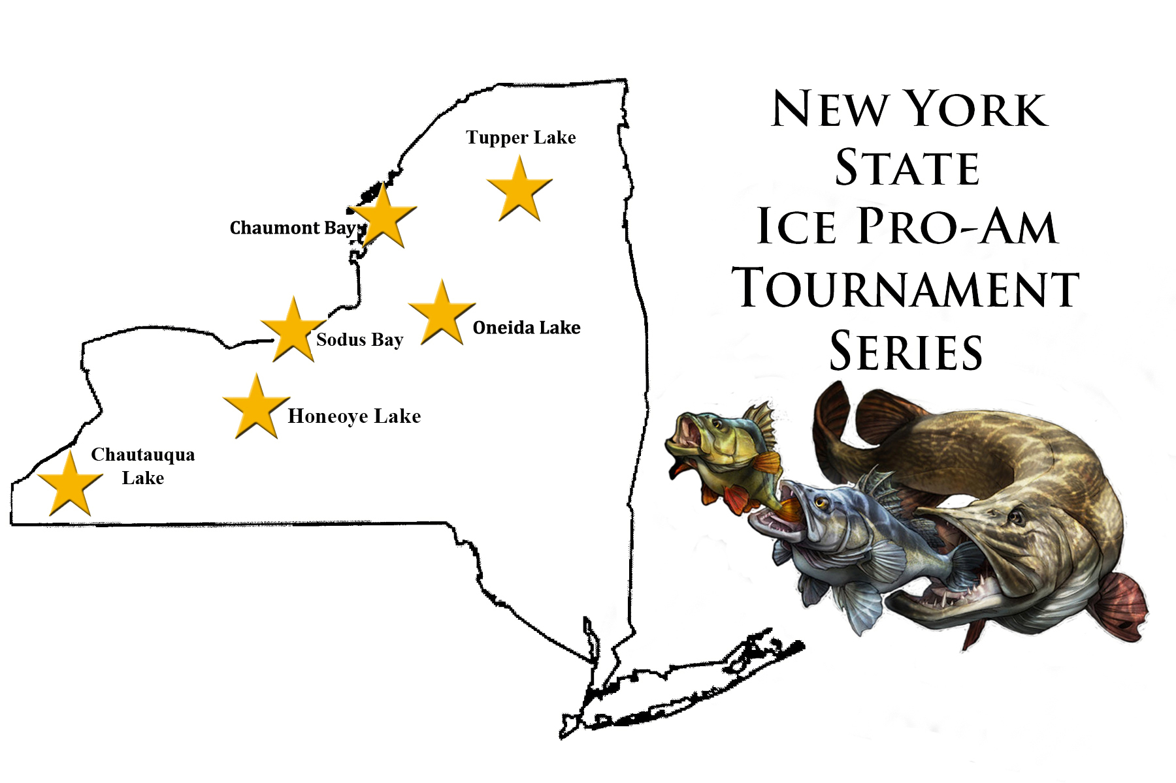

And
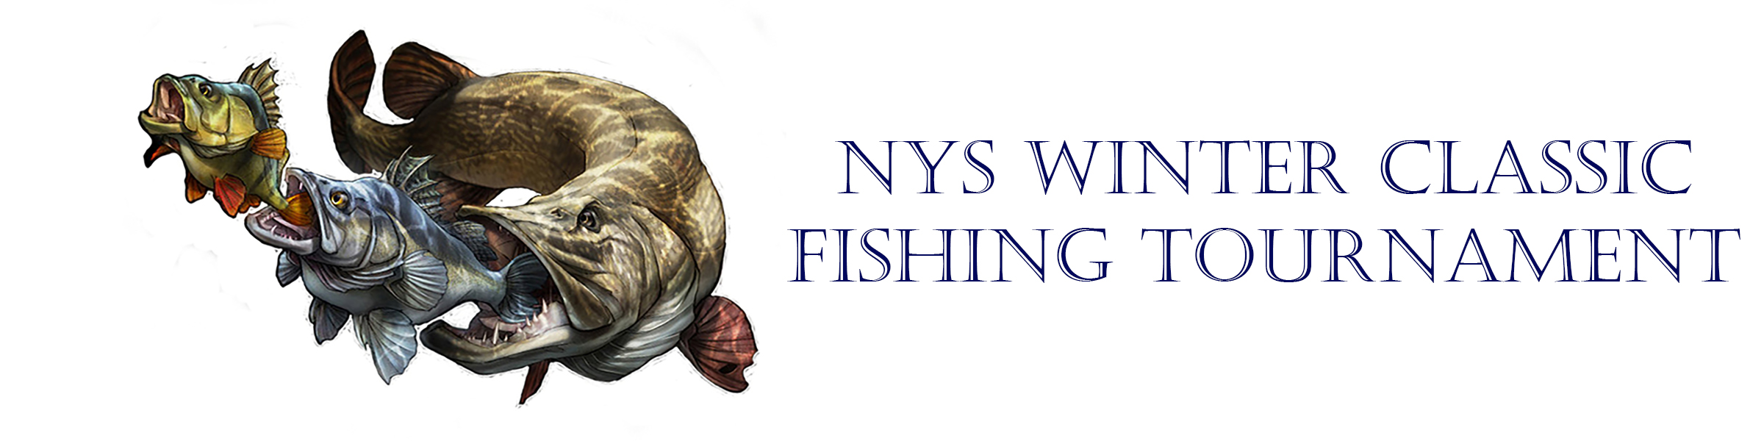

Presented and Directed by
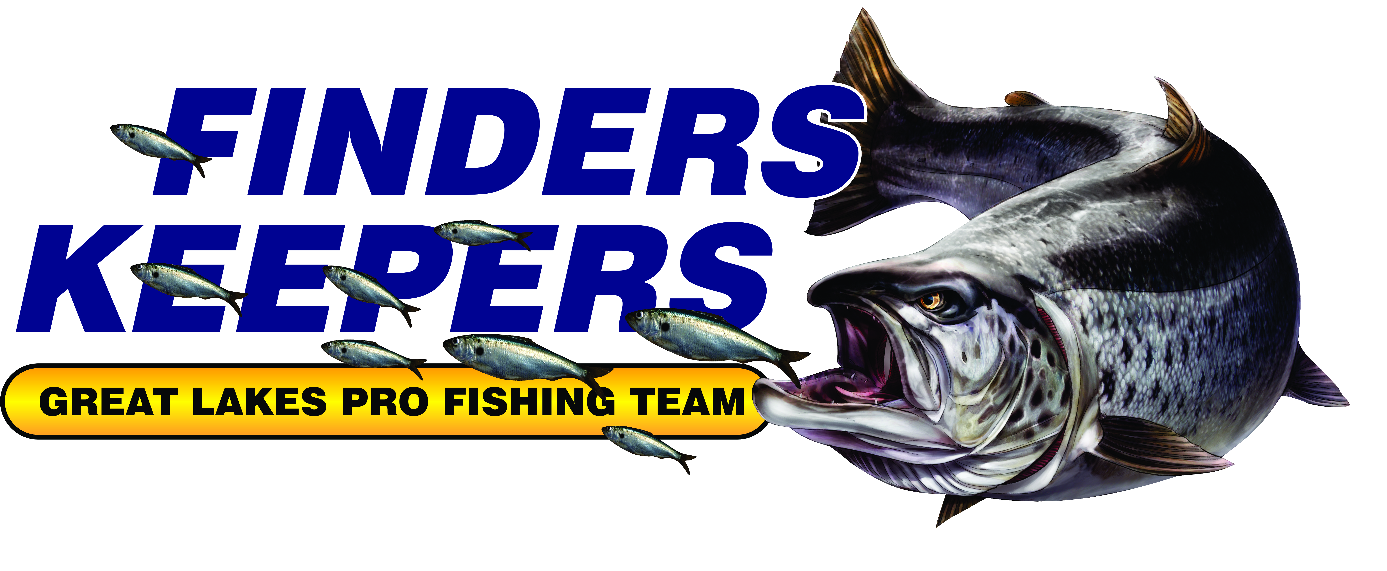

TOURNAMENT SPONSORSHIP PACKET
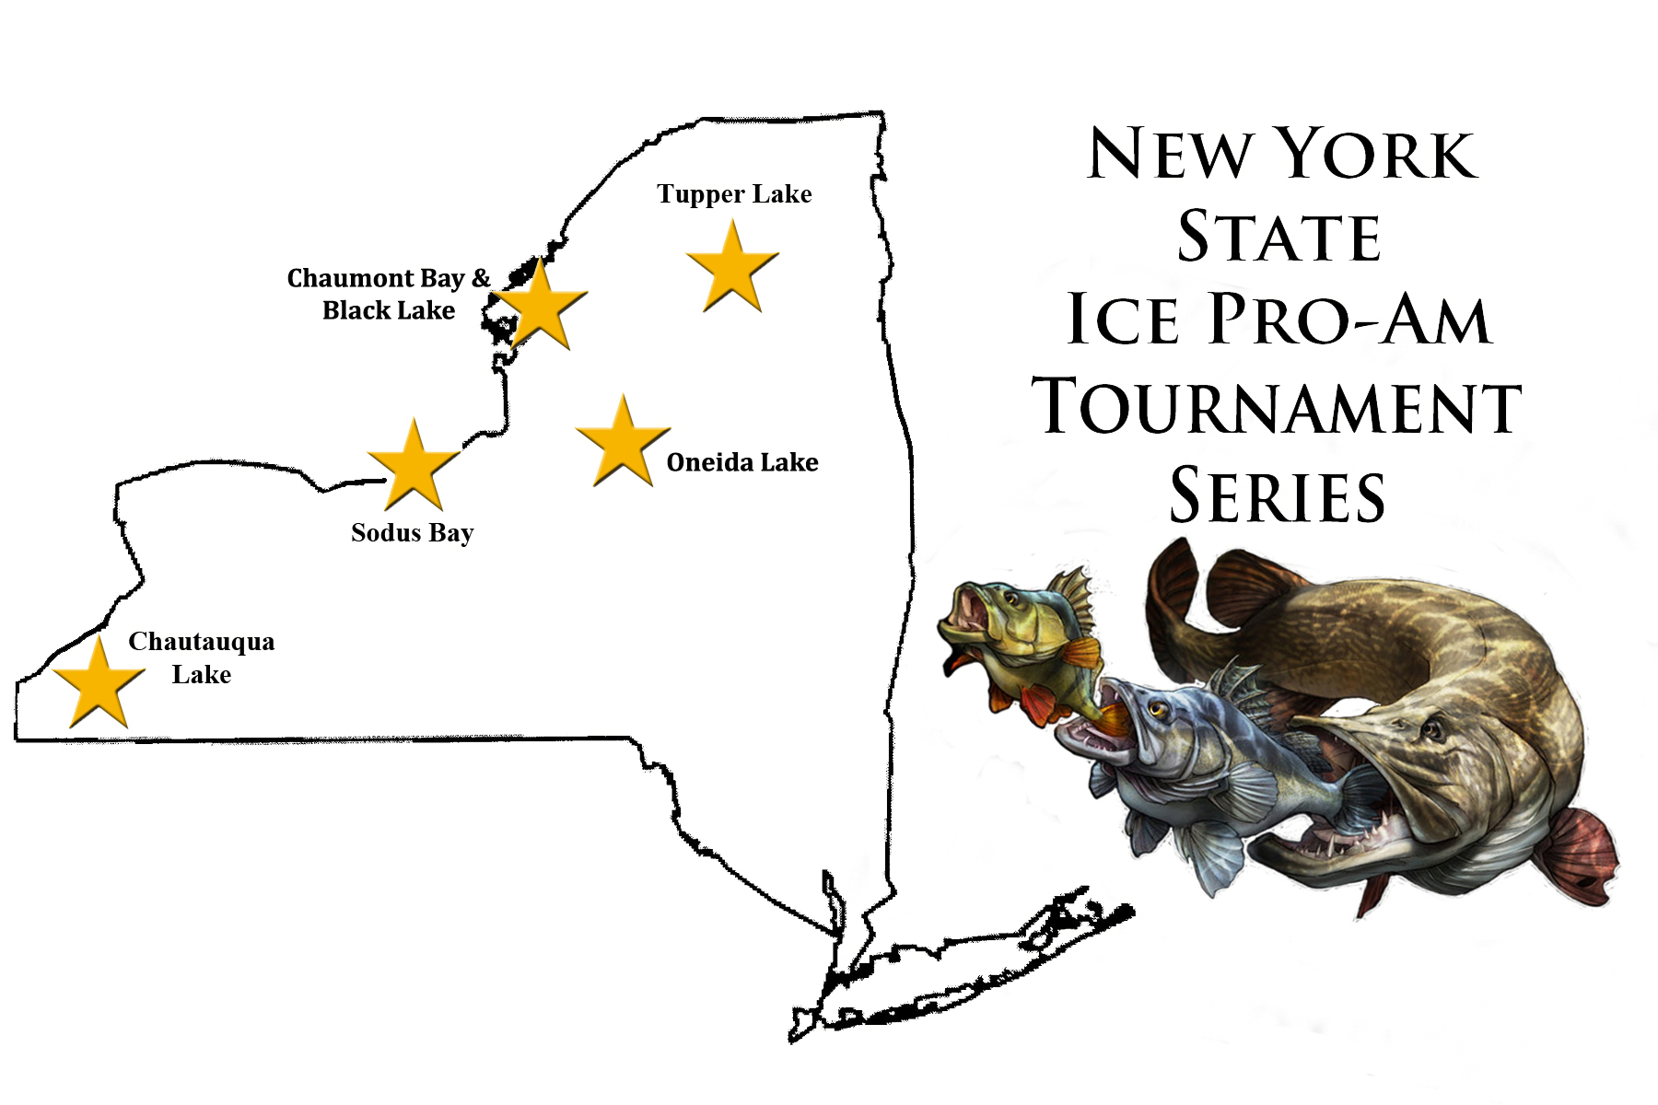
NYS Ice Pro-Am Tournament Series

MISSION
Our mission is to provide a professionally run series of ice fishing tournaments that have as little an impact on the fisheries as possible through catch & release practices, stimulates and supports the local communities, offers exposure for our world-class fishery and our supporting sponsors, and supports organizations which help youth become engaged in the sport of fishing

SPONSORSHIP OBJECTIVES
Events of this magnitude have substantial short-term and long-term economic impacts on the local economies and educational impact on the community. Sponsorship will help generate interest in the events, which in turn will have a direct impact on the local economies within which the events are taking place, and provide our Sponsors with an avenue to inform and educate. Building a strong relationship with Sponsoring companies will cultivate a growing interest in the NYS fishery and the sport of fishing. Sponsors will be featured and highlighted before thousands of anglers through the use of multi-media connections including news and radio broadcasts, seminars, printed materials and publications, and the internet.

ICE PRO-AM TOURNAMENT SERIES
The NYS Ice Pro-Am Tournament Series was conceptualized from the lack of any substantial ice tournament series in NYS. This Tournament Series consists of large ice fishing events (called “Full IPA Events”) and smaller team events (called “Team-Only Events”). The Full IPA Events are Pro-Am style events spanning 2-days, and feature two Divisions: Pro-Am and Open. The Open Division is run like a general tournament, where the largest five fish for each species place in the tournament. This Division is geared towards the weekend anglers and novice ice fishermen, and each angler is considered a competitor. The Pro-Am Division is scored on a point system and requires the anglers (single or two-person teams) to catch multiple species to score points. The top five teams in the Division with the most points place in the tournament. The Pro-Am Division is geared for those anglers who are sponsored by fishing companies and/or who crave the highest level of competition with the greatest pay-out. Each event is expected to attract 100’s of Open Division anglers (based on other current similar tournaments to our Open

NYS Ice Pro-Am Tournament Series

Division in NYS) and 25+ Pro-Am teams (projected based on angler surveys and participation during the previous seasons). Our 2-tier structure caters to anglers of all skill and ambition levels, attracting a larger number of anglers than most other ice fishing tournaments. This offers our Sponsors the ability to promote their products and literature to a large target audience. In addition, from our experience as professional tournament fishermen and from angler surveys, we have added features like formal awards ceremonies, youth angler clinics/camps (proposed for future events), substantial prize packages and trophy awards, and ties to local community organizations that set our series apart from all others in NYS.

Statewide Winter Classic Tournament
The NYS Winter Classic Tournament is open to anglers of all skill levels fishing across the entire state of NY, where they can fish on the ice, in the open water, or on any of the tributaries of NYS. The main concept behind the tournament structure was to eliminate many obstacles often encountered when running tournaments in the winter (like lack of safe ice) while covering a wide range of waterways to appeal to different angling methods. This is the largest (in scope) of any winter tournament ever run in NYS with a huge prize potential based on angler participation. A large number of awards/prizes are featured in this event (including overall, monthly, weekly, local, and door prizes) that add to its attractiveness for anglers.

SEMINAR SERIES
As professional anglers, we present several free seminars throughout the year at the Bass Pro Shops store in Auburn, NY, the Field & Stream store in Rochester, NY, and other various local tackle shops on angling tactics, techniques, and product demonstrations. Most of our seminars are unique, in that we engage the attendees in hands-on activities (usually associated with product promotions) using our tournament boat (for open water applications) and tournament ice gear (for hard water applications). Sponsor’s products are also showcased and demonstrated within the series (as appropriate) and literature given out to interested anglers. When Sponsors’ products are presented to perspective anglers by professional fishermen, this is a very persuasive educational tool that then connects the anglers with the Sponsors’ products. Plus they’ll be able to use the gear properly for a much more positive experience in the field. This year we will again be featuring seminars on the Friday before each full IPA event where sponsors can send representatives (or product to us) to present their new gear, tactics, etc. to those fishing our
NYS Ice Pro-Am Tournament Series

events. This will provide our sponsors a spotlight opportunity with a targeted audience to showcase their products.

BRAND RECOGNITION
The NYS Ice Pro-Am Tournament Series and NYS Winter Classic continue to build their media presence yielding ever higher numbers of consumer impressions across all media. Sponsoring companies build the tournament’s support structure yielding higher angler confidence, support, and participation, and help to ensure the tournaments’ longevity.

HIGH PROFILE MEDIA PRESENCE
National, regional and local press releases are generated and released throughout the year. Our tournament events have been highlighted and featured on The Outdoor Beat TV Show, Grizzly Gary’s Radio Show, Let’s Catch Fish Radio Show, NY Outdoor Talk, Fox Rochester’s Friendliest Catch Program, News 8 broadcasts, and several other on-air and internet radio shows, in addition to many local and national press articles.

TOURNAMENT WEBSITES
www.NYSiceproam.com and www.NYSwinterclassic.com

The NYS Ice Pro-Am Tournament and NYS Winter Classic Tournament websites feature tournament information, news, updates, leaderboards, past years’ results, geographic information about the waterways, maps, local interests, and is laden with the logos of our Sponsors with links to their respective sites. We also highlight various sponsors and their products when they are related to specific prizes or awards as the event leads up to its conclusion.

TRADE SHOWS AND INDUSTRY EVENTS
The NYS Ice Pro-Am Tournament directors attend local sportsman show(s) that contain an emphasis on ice fishing. The tournament sponsor billboards are displayed with all sponsoring company’s logos clearly visible and borders the backdrop to our display at all seminars, shows, and event awards ceremonies.

NYS Ice Pro-Am Tournament Series

ADS, FLIERS, BANNERS
Before and during each season, thousands of fliers and eye-catching posters are produced and distributed across NYS featuring the logos of our event sponsors. Tournament banners and/or signs are also displayed in key tackle shops (those which act as weigh-in locations for the state tournament) located near each major waterway throughout the year.

SPONSORSHIP PACKAGES
Winter Classic Title Sponsor
The Winter Classic Title Sponsor is the company or entity that provides substantial funding. The retail value of the sponsorship is in access of $20,000/yr with a minimum 3-year commitment. In return, the sponsoring company receives the following:
- The Tournament Title will be changed to include the sponsoring entity’s name.
- The largest logo placed on Winter Classic awards billboards.
- Logo inclusion on all circulated fliers, advertisements, tournament website home page and event pages, and all other advertising displays.
- Custom options are available for those looking to fund particular pieces of the tournament (i.e. the awards projection screen, Triple Crown Trophy, etc.).
- Mentions within the tournament video series and advertisements, promotional videos associated with Fox Rochester’s Friendliest Catch Program, within seminars and presentations associated with the tournament, and other media avenues.
- Invited to present & showcase product(s) at one or more of the pre-event seminars.
- Company banners will be hung at the events and/or awards ceremonies.
- Company brochures can be handed out at registration and included in awards packages and captain packs.
- Inclusion of full-page ad (or back cover) within the tournament highlights magazine (when available).

NYS Ice Pro-Am Tournament Series

Series Title Sponsor
The Series Title Sponsor provides substantial funding that benefits the entire tournament series. The retail value of the sponsorship is in access of $10,000/yr with a significant funding portion and minimum 3-year commitment. In return, the sponsoring company receives the following:
- The Series Title will be changed to include the sponsoring entity’s name.
- The largest logo placed on both Series’ awards billboards.
- Logo inclusion on all circulated fliers, advertisements, tournament website home page and event pages, and all other advertising displays.
- Custom options are available for those looking to fund particular pieces of the tournament (i.e. the awards projection screen, Triple Crown Trophy, etc.).
- Mentions within the tournament video series and advertisements, promotional videos associated with Fox Rochester’s Friendliest Catch Program, within seminars and presentations associated with the tournament, and other media avenues.
- Invited to present & showcase product(s) at one or more of the pre-event seminars.
- Company banners will be hung at the events and/or awards ceremonies.
- Company brochures can be handed out at registration and included within the prize packages and captain packs.
- Inclusion of full-page ad within the tournament highlights magazine (when available).

NYS Ice Pro-Am Tournament Series

Series Headlining Sponsor
Series Headlining Sponsors are those that provide substantial funding, services, and/or products that benefit the entire tournament series. The retail value of the sponsorship is in access of $5,000/yr. In return, the sponsoring company receives the following:
- XL logo placed on both awards billboards.
- Logo inclusion on all circulated fliers, advertisements, tournament website home page and event pages, and all other advertising displays.
- Custom options are available for those looking to fund particular pieces of the tournament (i.e. the awards projection screen, Triple Crown Trophy, etc.).
- Mentions within the tournament video series and advertisements, promotional videos associated with Fox Rochester’s Friendliest Catch Program, within seminars and presentations associated with the tournament, and other media avenues.
- Invited to present & showcase product(s) at one or more of the pre-event seminars.
- Company banners can be hung at the events and/or awards ceremonies (when provided).
- Company brochures can be handed out at registration and included within the prize packages and captain packs.
- Inclusion of full-page ad within the tournament highlights magazine (when available).

Key Display Piece Series Sponsor
Key Display Piece Series Sponsors are those that provide funding for distinct display items that will become mainstays for the tournament and are high-visibility items providing vast exposure for the sponsoring company. These can be negotiated as a multi-year sponsorship. At this time we are looking for funding for the following items:
- Tournament Display Trailer (~$10,000): A graphics wrapped 20’ v-nose trailer with dual ramps, finished interior, and exterior lighting. Graphics will feature the sponsoring company, who will also give approval for the wrap design. The trailer will be used to transport supplies across the state multiple times per year, transport equipment for tournament events, machines, etc. for running our tournament events, participating in additional tournaments, displays at ceremonies, outdoor shows and other advertising events, and to display at any other advertising opportunities.

NYS Ice Pro-Am Tournament Series

- Awards Ceremony Truss & Screen System ($7,500): The backdrop of our awards ceremony is what captivates our anglers when they arrive for the awards ceremonies. It is the backdrop to all of the pictures and videos taken during the awards ceremony, and it
is one of the key components to delivering a prestigious, awe-inspiring appeal to our awards ceremonies. The system consists of a Draper truss-style cinefold portable projection screen, with anti-sway stabilizers, HD leg braces, truss stiffener bars, and a dress kit.
- Series Championship Triple Crown Cup Trophy ($400): Awarded to the Pro-Am Team that finishes with the highest cumulative score from at least three tournament events that will be deemed the Series Grand Prize Winning Team. The trophy will be a substantial cup-style metallic trophy purchased from NYRA Awards in Rochester, NY.
- Sony HXR-NX70U NXCAM w/ Wireless Mic System ($5,000): Being able to shoot hi-definition video and pictures is the key to capturing the spirit of the events and portraying that sense of excitement to other anglers through promotional videos. It would also allow for an easier transfer to other media outlets (news stations, etc.) for further exposure. All videos would list the sponsoring company’s name/logo.

In return, the sponsoring company receives the following:
- Extensive, long-lasting exposure for the life of the item.
- XL logo centrally placed on one or both awards billboards and on sponsored item (Trailer & Truss system).
- Logo inclusion on all circulated fliers, advertisements, tournament website home page and event pages, and all other advertising displays.
- Mentions within the promotional videos associated with Fox Rochester’s Friendliest Catch Program, within seminars and presentations associated with the tournament, and other media avenues.
- Company banners can be hung at the events and/or awards ceremonies (if provided).
- Company brochures can be handed out at registration and included within the prize structure and captain packs.
- Inclusion of story within the tournament highlights magazine (when available) highlighting the sponsored piece and spotlighting the sponsored company.

NYS Ice Pro-Am Tournament Series

Series Event Title Sponsor
Series Event Title Sponsors are those that provide substantial funding that benefits a single tournament series event. The retail value of the sponsorship is in access of $5,000. In return, the sponsoring company receives the following:
- The series event name will be changed to include the sponsoring company’s name.
- XL logo placed on one or both awards billboards.
- Logo inclusion on all circulated fliers, advertisements, tournament website home page and event pages, and all other advertising displays.
- Mentions within the tournament video series and advertisements, promotional videos associated with Fox Rochester’s Friendliest Catch Program, within seminars and
presentations associated with the tournament, and other media avenues associated with the sponsored event.
- Invited to present & showcase product(s) at one or more of the pre-event seminars.
- Company banners can be hung at the events and/or awards ceremonies (when provided).
- Company brochures can be handed out at registration and included within the prize packages and captain packs.
- Inclusion of full-page ad within the tournament highlights magazine (when available).

Platinum Series Sponsor
Platinum Series Sponsors are those that provide funding, services, products, and/or discounted goods that benefit the entire tournament series. The retail value of the sponsorship is in access of $2500. In return, the sponsoring company receives the following:
- XL logo centrally placed on one awards billboard.
- Logo inclusion on all circulated fliers, advertisements, tournament website home page and event pages, and all other advertising displays.
- Custom options are available for those looking to fund particular pieces of the tournament (i.e. the awards projection screen, Triple Crown Trophy, etc.).
- Mentions within the promotional videos associated with Fox Rochester’s Friendliest Catch Program, within seminars and presentations associated with the tournament, and other media avenues.
- Company banners can be hung at the events and/or awards ceremonies (when provided).
NYS Ice Pro-Am Tournament Series

- Company brochures can be handed out at registration and included within the prize structure and captain packs.
- Inclusion of 1/4-page ad within the tournament highlights magazine (when available).
- Ability to showcase products during pre-event seminars.

Gold Event Sponsor
Event Sponsors are those that provide funding, services, and/or goods that benefit at least one or two specific events within the tournament series. The retail value of the sponsorship is in access of $500. In return, the sponsoring company receives the following:
- Large logo placed on an awards billboard.
- Logo inclusion on all event-specific circulated fliers, advertisements, and tournament website event pages.
- Mentions within the promotional videos associated with Rochester’s Friendliest Catch Program, within seminars and presentations associated with the tournament, and other media avenues
- Company banners can be hung at the events and/or awards ceremonies (when provided).
- Company brochures can be handed out at registration.
- Ability to showcase products during pre-event seminars.

Silver General Sponsor
General Sponsors are those that provide funding, services, and/or goods that benefit the tournament series on a small scale. The retail value of the sponsorship is less than $500. In return, the sponsoring company receives the following:
- Small logo placed on an awards billboard.
- Name or logo inclusion on tournament media pages as appropriate and pending space availability.

NYS Ice Pro-Am Tournament Series

Other Sponsor Options
Due to the extensive nature of our events, we can offer specialized sponsor packages and options within and beyond the levels listed above. Examples include titling the leaderboard for the statewide tournament, offering a Grand Prize Award or weekly cash awards, etc. All sponsorship ideas are welcome and can be negotiated.

CONTACT INFORMATION
Tim Thomas
President & Tournament Director
info@fksportfishing.com
585.330.0494

Jennifer Thomas
Tournament Manager
info@fksportfishing.com
585.330.1021

